Te Tāruke-ā-Tāwhiri: Auckland’s Climate Action Framework

The following is a response to the framework from two workshops held at the University of Auckland. The workshops were open to graduate students and staff from across the University and there were 37 participants in all. The names and affiliations of the workshop participants and others who were part of the consultation process appear at the end of this document. We wish to note that this response does not represent a consensus of the views shared amongst the people involved. Instead it offers ideas for consideration by Auckland Council (AC). It is also not a formal response from the University of Auckland and should not be taken to represent the university’s view.

The facilitators of the workshops and contacts for further information are:
Professor Niki Harré, n.harre@auckland.ac.nz
Dr Stephen Knight-Lenihan, s.knight-lenihan@auckland.ac.nz

Julie Maskill assisted with the collation of responses.

1. Te Tāruke-ā-Tāwhiri Auckland’s Climate Action Framework provides a guide to address the climate crisis. The framework has 11 changes called key moves to reduce our emissions and the impacts of climate change. The key moves set out actions that every Aucklander – from residents to businesses – need to be involved in.
Do you think the framework takes us in the right direction to act on climate change?

We are highly supportive of AC’s attempt to develop a comprehensive action framework. As commented in one of our workshops AC, along with organisations across the city, needs to develop ‘climate change glasses’ and so consider climate change in all their planning and activities. A parallel is the successful incorporation of health and safety at work into organisational culture, where mechanisms used include relevant policies and procedures in staff manuals as well as higher level reports on the health and safety implications of major decisions. The proposed Climate Action Framework goes a long way towards developing ‘climate change glasses’. More specific comments appear below.

2. To develop this framework, Auckland Council worked alongside central government, other councils, Māori as kaitiaki, the private sector, ngā rangatahi and Aucklanders. While we will own the delivery of some actions, we cannot deliver them all. For this framework to be successful, there needs to be facilitation across these groups.

Do you think Auckland Council should facilitate action and bring together those that can deliver on the framework?

Yes. There was strong support for integration at both our workshops. This included working alongside central government to ensure that national legislation supports local efforts to mitigate and adapt to climate change and to reduce fragmented responsibilities and governance structures. Examples include ensuring Council Controlled Organisations actions are fully integrated with AC targets and strategies to adapt to, and reduce the risk of, climate change. While there was a view expressed that AC should concentrate on its core business (such as transport planning) other participants referred to examples where the constraints on local government’s powers to reduce emissions and promote adaptation are so considerable that it is essential for them to liaise with central government.

Examples given of priority areas for AC input included the Climate Change Response (Zero Carbon) Amendment Bill, and the proposed review of the Resource Management system, including the RM Act itself. The objective is to ensure local government can contribute to both reducing emissions as well as adapting to impacts. Other relevant legislation includes the Building Act and Local Government Act. AC’s involvement could include providing evidence on the limits to climate action imposed by current legislation and potential legislative improvements.

Some participants also commented on the need to breakdown silos within the council and council agencies such as Auckland Transport (AT). This would allow for the needed level of integration between transport, land use and urban development.

There was support for integrated planning in regard to the key moves. For example, there is potential to integrate key move 4 (Transform existing buildings and places) and key move 10 (Shift to decentralised renewable energy) with legislation that could be negotiated with central government. One tool that is worthy of consideration is the UK’s Merton Rule. Introduced in the 2003 Merton Local Plan, the rule required larger commercial developments to generate at least 10% of their energy from renewable sources on site. This had the indirect impact of significantly increasing energy performance of new buildings, way above the Building Standards. Over time this rule has been extended to other types of development with higher % requirements. 2008 legislation enabled all English and Welsh local councils to adopt such a rule. Education efforts including working alongside schools via the Sustainable Schools team at AC and programmes such as Live Lightly, could also help maximise the potential benefits of many, if not all, key moves. For example, in key move 11 (Grow a low-carbon, resilient food system) AC could educate on ecologically sustainable farming practices and regenerative management.

3. Key Moves. The framework has 11 key moves - to reduce Auckland’s emissions and the impacts of climate change.
Do you think these are the right key moves for Auckland?
We were generally supportive of the key moves, some participants noted an additional key move that specifically addresses the equity outcome outlined is needed. We elaborate on this further in conjunction with our response to question 4.

4. The framework sets out a range of actions that organisations and businesses can be involved in delivering. These moves and actions include how to build resilience, developing a zero-carbon business model, how to procure products and how to deal with waste.
Do you think that the key moves will drive business and organisational action?

We comment below on our response to a selection of the key moves and actions proposed.

A further comment is that AC consider more sensitive monitoring measures that will pick up the impact of the often small scale actions proposed on Auckland’s emissions targets. See for example CarbonWatch NZ, https://www.niwa.co.nz/climate/research-projects/carbon-watch-nz).

Key move 1 - Lay the foundation

As well as the integration with central government and within AC agencies discussed above, one suggestion is an ongoing Climate Change Agency operating outside the Council as an advisory body.

The establishment of such an agency would acknowledge the complexity, scale, importance and required long-term nature of AC’s task to reduce the region’s climate change emissions. This agency should be independent and bipartisan allowing it to survive changes in political incumbents. The new agency would be charged with the following tasks:
- Auditing AC’s climate action performance
- Identifying opportunities for better outcomes
- Developing mechanisms to assess the Climate Change implications of AC’s decisions and ensuring these are used in all planning processes
- Monitoring and advising on integration efforts including those across divisions within AC’s organisation/s; between AC and related organisations in its area, including Council Controlled Organisations; between AC and other local authorities; between AC and national level government, governance, economy, voluntary sectors; and between AC and international communities
- Including operating emissions as a cost (use climate integrated accounting) to cease the current externalising of emissions.

Participants commented that such an agency would prioritise action, and not simply or primarily provide continuous, on-going reviews and re-statements.

Key move 2 - Enhance, restore and connect our natural environments

The following suggestions were offered:

- Communicate key examples of AC’s leadership and what has already been achieved, e.g. Sea Change and the achievement of one million tree plantings. This would help inspire other related actions and encourage coordination across climate change related efforts.

- Support community initiatives – participants emphasised the value of growing AC’s role in supporting community and local restoration projects, with practical resources such as funding for co-ordinators, model guidelines for organisations’ rules, providing examples of successful case studies, opportunities for practical restoration work, and data bases for group co-ordination.

- Grow the Sustainable Schools team – participants expressed concern about the reduced capacity of the team to meet needs in schools, and proposed prioritising building and strengthening the team. This could include reinstating the successful Make a Difference youth environmental leadership programme including its residential camp to facilitate identities and youth networks for sustainability.

- Set up systems that support behaviour that protects natural environments – e.g. a protective regulatory environment where it is more difficult to cut down mature, endemic trees (possibly including financial incentives to retain and disincentives to cut down such trees).

- Add emphasis on the functional importance of the ocean and Hauraki Gulf in regulating climate, mitigating the impact of sea level rise (for example looking at the opportunities and limitations for ‘soft engineering’ to protect coasts) and interfacing with food systems.

- Advocate for legal and policy change at central government level that recognises the interdependence of people and eco-systems

- Prioritise communicating to/with Aucklanders about the interdependence of people and eco-systems

- Expand the one million trees planting program to try to cover as much available land as possible across the Auckland region with trees, given recent research showing the huge effect on climate change tree planting could have (Bastin et al 2019, https://science.sciencemag.org/content/365/6448/76) and the availability of maps indicating where such planting would be most beneficial (https://www.crowtherlab.com/maps-2/)

- Clarify what each of the actions suggested under this key move will achieve in terms of emissions reductions. This applies in particular to the flagship action to regenerate Manukau’s blue and green networks.

Key move 3 - Make development and infrastructure climate compatible

- Ensure that new developments are only approved in tandem with public transport accessibility.

Introduce legislation and planning approval processes that require an ecosystem analysis and best practice for all substantial developments. Whilst some features have been included in the Wynyard Quarter, the Council could draw on some of the deeper lessons from Hammarby Sjöstad in Stockholm, which is one of the most advanced exemplars of eco-system development.
(see https://hammarbysjostad20.se/wp-content/uploads/2019/06/Hammarby-Sjostad_report_eng.pdf; Fraker, H, Chapter 3 in The Hidden Potential of Sustainable Neighbourhoods: Lessons from low-carbon communities, Island Press, 2013.)

The image below is from GlashusEtt – the education and information centre at Hammarby.

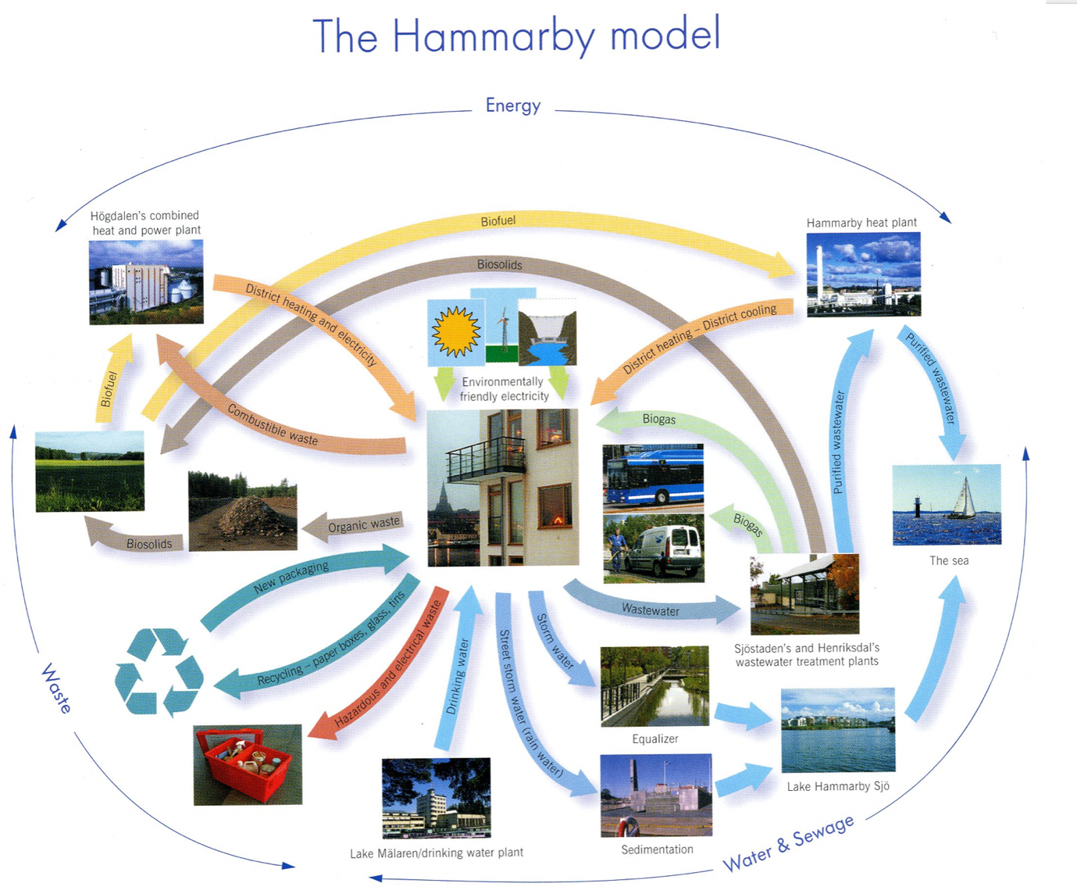

Key move 4 - Transform existing buildings and places

- Advocate for necessary changes to the RMA and Building Acts to require building practices that reduce and offset GHG emissions and allow for the adaptations likely required over the next 200 years.

- Prioritise higher density use of existing buildings and new developments, including facilitating the development and instigation of a legal model for co-housing/papakāinga arrangements as well as supporting this option in the planning system.

- Prioritise building quality, design and longevity as essential conditions for increasing density

- Ensure all developments are considered in tandem with the other key moves.

Key move 5 - Deliver clean, safe and equitable transport options

This key move was generally viewed positively but it was noted that the
‘actions’ in the document are goals, not actions, and therefore it will be important to develop actual actions.

- Some participants felt that this key move should have top priority given the contribution of transport to GHG emissions and transport being part of the core business of AC. AC was seen to already have many levers for improving transport emissions profile within its control. However, again a key component will be better integration with the CCO AT to establish clear mutual intermediate and long-term goals.

- Reorder the actions, with public transport and cycling and walking infrastructure given greater immediate priority than the uptake of zero and low emissions vehicles. The former is core business of AC and requires detailed planning and financial priority. Furthermore, it is essential that cycling, walking and public transport are given priority in other core areas of council business, such as building developments.

- Emphasise the health benefits of active transport in decision making and educational campaigns.

- Prioritise a ‘walkable city’ in urban design – e.g. high quality, well-surfaced, well-maintained footpaths, trees for shade, pocket parks with seating to take a break, lighting for safety. Address psychological barriers in designing walkability.

- Promote use of public transport by making it more reliable, accessible and attractive; incentivise active transport and use of public transport (e.g. through employee subsidies or bonuses for not using a carpark); accommodate bicycles at workplaces; remove perverse incentives to use cars, such as by providing parking at workplaces and having discounted early bird rates.

- Involve employees in designing better facilities for active transport.

- Use sticks as well as carrots to incentivise low emission transport choices – e.g. reduce carparks and increase the costs of parking in the inner city and shopping areas.

- Develop more suburban hubs – to connect to trains with feeder buses. These should include bike storage and those in the outer suburbs should also include free parking.

- Make better accommodation for users of multi-modal transport options, for example: divide cycle ways to accommodate various types of users – e.g. scooters, pedestrians and provide helmet drop offs/collection points for scooter users.

- Emphasise an overall reduction in vehicle numbers – this should over-ride/run in parallel with the suggested action 1 ‘Encouraging large-scale up take of zero and low emissions vehicles’.

- Promote electric vehicle privileges relative to petrol vehicles. This is a balance however, as many participants felt cyclists, walkers and public transport users should be advantaged relative to private vehicle users (no matter what energy source the latter are using).

- Ensure that the transport needs of socially vulnerable people are included in all transport planning. This includes recognising that people’s choices are limited by location and economic and other circumstances.

- Make train travel more attractive by allowing users to be more productive while travelling. This could include installing permanent or fold down tables: Install a small fold down table on the back of selected chairs. This table would look and function much like one you find on an aeroplane. If employers knew that those commuting on passenger trains had an effective station to set up and work at, they could be willing to let this contribute to an employer’s hours. Students could also use these facilities for homework. It is noted that not all seats would be able to accommodate a fold down table, such as those in the aisle. If there is concern about the treatment of these tables on the trains (e.g. commuters leaving rubbish on them) perhaps a system which allows for the tracking of ‘table users’ would help to deter this behaviour. For example, an electronic lock which can be deactivated by swiping ones Hop card.

- To further assist commuters with working on the trains, free WiFi and USB or three pin plugs would be great additions.

Key move 6 - Move to a zero carbon, climate resilient economy

- Restructure workplace organisation to incentivise employers to reduce employee contributions to rush-hour congestion and associated increased emissions where compatible with workplace demands, through for example: a staged introduction of working at home 2-3 days per week, staggered working day and school start/finish times, using early adopters as pilots to demonstrate viability and logistics, and shifting culture and practice around workplace organisation to reflect and highlight the climate emergency.

- Prioritise actions that will substantially reduce individual travel as a principle for planning policy. This includes reducing the geographical fragmentation of places where different aspects of economic and social life occur, e.g. work, school, buying and eating food. Incentivise multiple land uses in neighbourhoods rather than centralising specific uses and segregating them from where people live (as, for example, with large shopping centres which reduce the viability of local shops within walking distance of customers).

- Support and advocate for equitable internet connectivity to facilitate working from home.

Key move 7 - Help Aucklanders become more resilient and reduce their carbon footprint

There was general approval of the framework’s content at a macro-level but more specific examples are required to demonstrate how reductions will be achieved. The absence of examples means it is unclear what this key move might mean at the micro-level. Suggestions are as follows.

- Adopt a clear GHG emissions reduction target and make it clear that everyone can play a role in achieving this. Regularly refer to the target in public facing communications. Lead by example with AC implementing all the practices they advocate including meat free catering, incentives for PT, walking and cycling for employees, and so on.

- Include progress on the GHG emissions reduction target in the Our Auckland magazine on p. 1 as a regular feature. Include examples of both organisations and individuals who have contributed towards the target. Have the target and our progress towards it as a standard feature on AC’s web homepage.

- Support a cultural shift with education, information, incentives and disincentives. Prioritise a communication and community engagement strategy for Aucklanders emphasising the urgent need for individual change to address the climate emergency, e.g. relating to food wastage, moving towards a more climate-friendly/ flexitarian diet, waste management (who really knows what can go into the blue bin?), recycling, house size expectations and related energy demands.

- Support local community compost initiatives with food waste bin collections being managed at the local level whenever possible. Employ and train local residents to collect and compost food scraps at community facilities that may be located in local parks and/or at schools.

- Research and address reluctance to use public transport in particular demographics - e.g. it seems that young adults may move away from PT once they leave education and join the workforce, but this may be reduced with incentives, for example, concession rates for all under 25s. Also, provide free public transport for all school and tertiary students on the principle that this will increase the chance of them being PT users for life.

- Incentivise older people to move to smaller homes – for example, AC could once again invest in council-owned, means-tested pensioner housing with communal gardens. Running costs for apartments and retirement villages are too expensive for some independent seniors who own large, cold homes which they can’t afford to maintain.

Key move 10 - Shift to decentralised, renewable energy

- A whole system, integrated approach is required along with de-centralisation. For example, quoting for inclusion of solar power mechanisms should be prescribed as mandatory for building construction and major refit projects.

- AC could take a role in supportive market mechanisms for installing and use of renewable energy technology.

- On-site generation - The Unitary Plan should follow a Merton Rule approach (see earlier comments) and require developments over a certain size to include a certain percentage of on-site energy generation for resilience.

- Identify options to replace diesel on-site generators with lower-emitting or carbon neutral options. This will rely on research clarifying actual emissions savings rather than assumed ones. Green hydrogen may be a viable option, with current research projects being undertaken in Taranaki and by the Ports of Auckland. Once a usable option is identified its use could be mandated in all Council operations, and encouraged elsewhere in Auckland. See:
https://ourauckland.aucklandcouncil.govt.nz/articles/news/2018/12/ports-of-auckland-to-build-auckland-s-first-hydrogen-production-and-refuelling-facility/

- Lead the way by phasing-out the diesel and petrol operated equipment used by Auckland Transport and Auckland Council. Currently AC uses ‘Mechanical’ methods as a form of weed control; weed-eaters, mowers and shredders. AT currently conducts ‘Mechanical sweeping’ of the footpaths and streets. Current equipment that adds to the air pollution of the city, such as petrol/diesel weed-eaters and leaf blowers could be replaced with rechargeable battery operated equipment where possible and as soon as possible.

- Advocate for changes to the Building Act to require/enable AC to require decentralised micro-generation of energy (see Key move 4).

- When possible, require buildings to orientate to the sun for passive heating and solar energy generation

Key move 11 - Grow a low-carbon, resilient food system

- Participants generally approved of the ranking of priorities for actions.

- Fully protect productive soils for food production consistent with the proposed National Policy Statement for Highly Productive Land. Versatile and elite soils which are capable of sustaining food production in AC’s area are scarce and need to be protected. Protective mechanisms for AC include planning tools that prohibit further sprawling greenfields building development and that favour increased density instead.

- Identify and relocate all productive top soil during building and other development - where resource consent has already been issued for development on potentially productive soil then that topsoil should be conserved and transported to farming areas. Prohibit sending topsoil to landfill.

- Reduce emissions by promoting food production for the local market - producing for export and creating demand for imported substitutes needlessly adds avoidable carbon emissions. AC should incentivise use of productive land in the area to supply for local food needs, for example, by discounting rates for land used to grow for the domestic market instead of export. (Note that rates targeting is already allowed).

- Promote diversification from dairy and meat production – these cause soil degradation and are responsible for high methane emissions.

- Promote soil health and resilience to climate change by promoting sustainable farming practices – use education to promote economic and climate resilience for farmers by establishing a rural regenerative farming training team, and provide expertise and transitional training for existing farmers, shifting them from a position of carbon emission to one of sequestration, and improving soil health by avoiding use of pesticides and herbicides that cause soil degradation. Incentivise and subsidise conventional farmers to move to organic farming methods.

- Promote urban biodiversity, revoke the ban on berm planting - facilitate and support more community training so that larger numbers of local residents are empowered to establish regenerative, biodiverse and carbon-sequestering wildflower and native planting patches. For example continue and expand support for For the Love of Bees, which runs a beekeeping school and public workshops on permaculture, composting etc.

- Promote and support more community gardens and regenerative farming education - support local food projects/ food resilience projects such as community gardens, vertical farming or food forests so they can operate on a large scale to reach a significant share of the population. For example, in Christchurch, public land was reclaimed by communities for fruit and nut trees (see 'Edible Paradise' documentary). In Auckland Griffith Garden has turned public urban space into a community garden where the general public can learn about gardening and composting techniques. It will be important to apply previous use criteria to establish the usability of land for edible gardens, as well as assessing effects of vehicle emissions on for example leafy vegetables. In some cases, overriding health concerns related to exposure to pollutants may rule out food production.

- Use all available Council-owned urban land to benefit biodiversity

- Promote urban farming - Increased support and funding for urban farming initiatives, with an emphasis on training participants in regenerative practices as well as making council-owned land available. In order to address the economic disparity currently woven into our food systems, it is vital that these seek to include and upskill those in less affluent communities, making provision for community-owned and operated farms.

- Promote research into local and regenerative food production - support local research into distributed and decentralized modes of production, with an emphasis on enabling small businesses and local production. For example, decentralised orchards using underused pieces of council-owned land to grow fruit trees while providing meaningful jobs, sequestering carbon and beautifying the cityscape.

- Increase support for establishment and maintenance of farmers’ markets - small scale, local food producers require support to sell volumes which are too small for supermarkets to buy.

- Prioritise action to promote the food system contribution of Hauraki Gulf - establish a research team to investigate the potential for community-owned and run marine permaculture in the Hauraki Gulf, growing edible seaweed and sequestering carbon. More here: https://whatsyour2040.com/marine-permaculture/

- Advocate to central government for country of origin food labelling - to help highlight the carbon footprint of foods and bring about behavioural shifts in Auckland consumers. ​

Proposed new key move: Key move 12 – To ensure equity in the response to climate change

Fairness and justice are essential approaches because otherwise the socially vulnerable will disproportionately bear the cost of transitioning to low emissions and the burden of the impact of climate change. Specific actions should be developed to ensure this and considered in tandem with the other key moves.

This move could build on the research undertaken by RIMU staff on Climate Change and social vulnerability. International examples of this approach:
- Barcelona’s Climate Plan 2018 is based on 4 pillars: (1) Mitigation, (2) Adaptation and Resilience, (3) Climate Justice and (4) Promoting Citizen Action. All strategies and actions within the plan are assessed against their contribution to all 4 pillars.
- Boston (USA) has taken a strong equity approach that states: Minority and low-income communities must not be disproportionately impacted by climate hazards, Benefits from climate mitigation and preparedness efforts should be shared equally among all groups of people. In practice this means, giving priority to increasing the resilience of vulnerable populations (see Boston Climate Action Plan 2014).
- Portland, USA: “ Climate Action through Equity” integrated into the Portland 2015 Climate Action Plan, See: https://www.adaptationclearinghouse.org/resources/climate-action-through-equity-the-integration-of-equity-in-the-portland-multnomah-county-2015-climate-action-plan.html

Contributors

As noted earlier, this document does not represent a consensus on the part of contributors, but the various ideas that came forward in workshops and in the later opportunity to comment further on our response. Those involved and their department, school or service division at the university were:

Professor Niki Harré (Psychology) – Co-facilitator and contact
Dr Stephen Knight-Lenihan (Planning) – Co-facilitator and contact
Dr Julie MacArthur (Politics)
Anoma Ratnayake (Faculty of Science)
Dr Sudip Ray (Chemistry)
Joe Fagan (Environment)
Alexandra Lowrey (Chemistry)
Dr Katie Parish-Virtue (Chemistry)
Pete Mayes (Faculty of Science)
Dan Kelly (Psychology)
Dr Lesley Stone (Sustainability Manager)
Professor Natasha Hamilton-Hart (Business)
Dr Kiti Suomalainen (Energy Centre)
Katie Marshall (Law)
Rachelle Pedersen (Psychology)
Julia Maskill (Planning)
Dr Sally Birdsall (Education)
Jonathan Klawitter (Computer Science)
Kaya Shlomi (Environment)
Laura Duntsch (Biological Sciences)
Dr Katharina Bauer (Auckland University Press)
Olivia Yates (Psychology)
Dr Alex Taylor (Psychology)
Yasir Demirbas (Psychology)
Marcus Rinaldi (Business)
Associate Professor Julie Rowland (Environment)
Dr Manuel Vallee (Sociology)
Anna Ma (Faculty of Arts/Sustainability Office)
Mark Neal (Property Services)
Dr Patricia Austin (Planning)
Many Zhu (Faculty of Creative Arts and Industries)
Professor Alistair Woodward (Epidemiology and Biostatistics)
Regan Duff (Business)
Nick Sargent (Architecture and Planning)
Dr Prue Taylor (Planning)
Associate Professor Alex Sims (Commercial Law)
Associate Professor Luitgard Schwendenmann
Professor Quentin Atkinson (Psychology)
Professor Gillian Lewis (Biological Sciences)

